**TUGAS PRAKTIKUM**

**PRAKTIKUM PAW**

**MODUL 7 “Laravel CRUD”**



|  |
| --- |
| **Disusun Oleh:**  Nama: Fikri Ainun Najib  NIM:200411100153  Kelas: PAW B  **Dosen Pengampu:**  Nama: Ach. Khozaimi, S.Kom., M.Kom  NIP: 19860926 201404 1 001  **Asisten Praktikum:**  Nama: Alief Fadhilah Athallariq  NIM: 180411100028 |

**PRODI TEKNIK INFORMATIKA**

**JURUSAN TEKNIK INFORMATIKA  
FAKULTAS TEKNIK**

**UNIVERSITAS TRUNOJOYO MADURA**

**2022**

1. **Soal:** Buatlah sebuah database mahasiswa yg berisi table dengan nama tbl_mahasiswa dengan record nrp, nama, email, dan alamat.

**Screenshoot:**

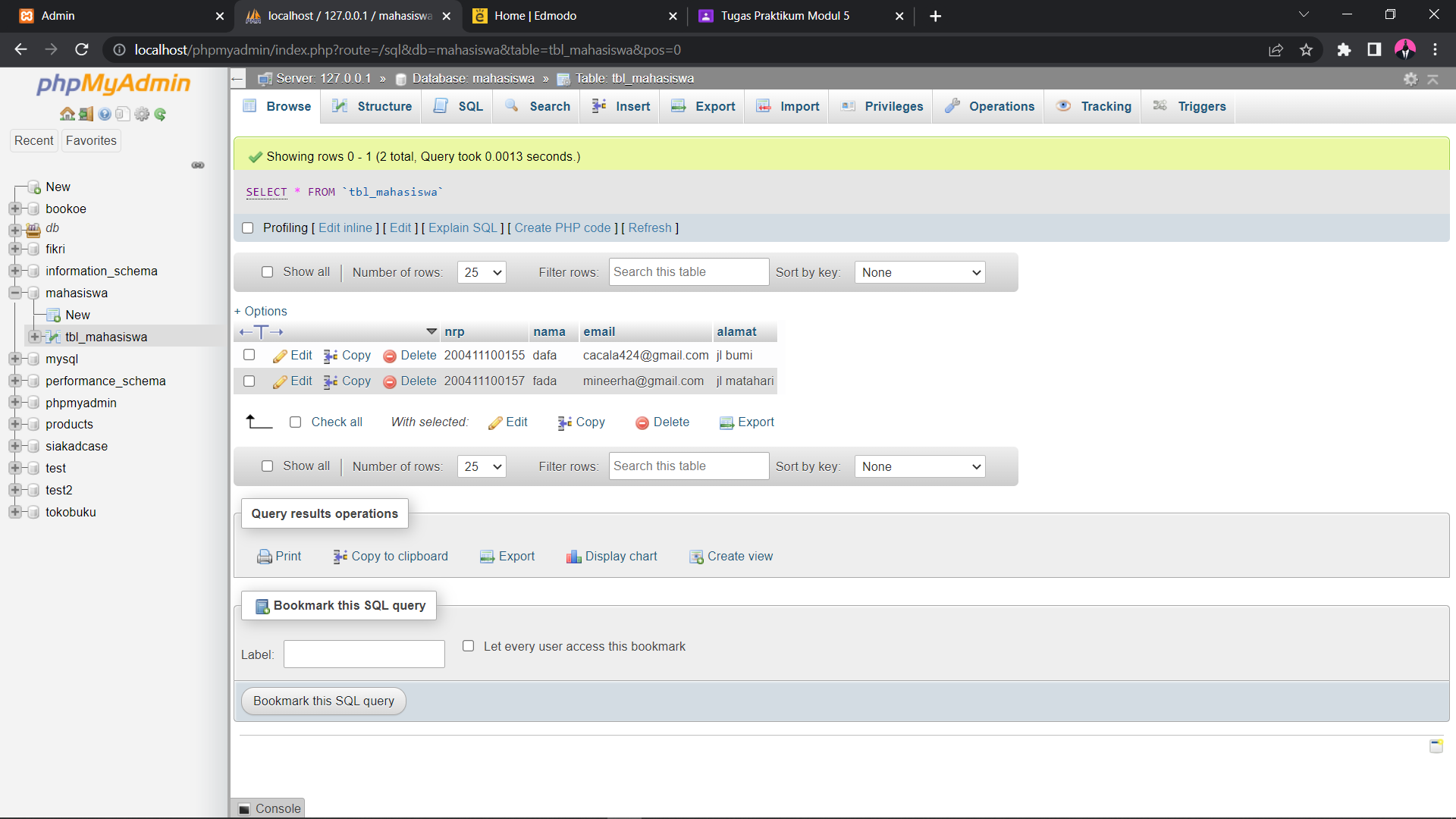

1. **Soal:** Buatlah beberapa file php yang dapat memasukkan, menampilkan, meng-update dan menghapus data yang ada dalam database mahasiswa tersebut!

**Source Code menampilkan:**

|  |
| --- |
| <?php  session_start();  require('database/connect.php');  $data = mysqli_query($conn, "SELECT * FROM tbl_mahasiswa");  $no = 1;  ?>  <!doctype html>  <html lang="en">  <head>  <!-- Required meta tags -->  <meta charset="utf-8">  <meta name="viewport" content="width=device-width, initial-scale=1">  <!-- Bootstrap CSS -->  <link href="https://cdn.jsdelivr.net/npm/bootstrap@5.1.3/dist/css/bootstrap.min.css" rel="stylesheet"  integrity="sha384-1BmE4kWBq78iYhFldvKuhfTAU6auU8tT94WrHftjDbrCEXSU1oBoqyl2QvZ6jIW3" crossorigin="anonymous">  <title>Admin</title>  </head>  <body>  <nav class="navbar navbar-expand-lg navbar-dark bg-dark">  <div class="container-fluid">  <a class="navbar-brand" href="#">Erha App</a>  <button class="navbar-toggler" type="button" data-bs-toggle="collapse"  data-bs-target="#navbarSupportedContent" aria-controls="navbarSupportedContent" aria-expanded="false"  aria-label="Toggle navigation">  <span class="navbar-toggler-icon"></span>  </button>  <div class="collapse navbar-collapse" id="navbarSupportedContent">  <ul class="navbar-nav me-auto mb-2 mb-lg-0">  <li class="nav-item">  <a class="nav-link active" aria-current="page" href="index.php">Home</a>  </li>  </ul>  </div>  </div>  </nav>  <div class="container">  <h1>Data Users</h1>  <?php  if (!empty($_SESSION['message'])) {  echo '<div class="alert alert-primary" role="alert">' . $_SESSION['message'] . '</div>';  unset($_SESSION['message']);  }  ?>  <a type="button" class="btn btn-primary" href="add.php">Add User</a>  <table class="table">  <thead>  <tr>  <th scope="col">#</th>  <th scope="col">Name</th>  <th scope="col">Username</th>  <th scope="col">Email</th>  <th scope="col">alamat</th>  <th scope="col">Action</th>  </tr>  </thead>  <?php  if (mysqli_num_rows($data) > 0) {  while ($row = mysqli_fetch_assoc($data)) {  echo '<tbody>';  echo '<tr>';  echo '<td>' . $no . '</td>';  echo '<td>' . $row['nrp'] . '</td>';  echo '<td>' . $row['nama'] . '</td>';  echo '<td>' . $row['email'] . '</td>';  echo '<td>' . $row['alamat'] . '</td>';  echo '<td>';  echo '<a type="button" class="btn btn-primary m-1" href="edit.php?nrp=' . $row['nrp'] . '">Edit</a>';  echo '<a type="button" class="btn btn-danger" onclick="return confirm(\'Really delete?\')" href="delete.php?nrp=' . $row['nrp'] . '">Delete</a>';  echo '</td>';  echo '</tr>';  echo '</tbody>';  $no++;  }  } else {  echo '<tr>';  echo '<td class="justify-content-center">No data</td>';  echo '</tr>';  }  ?>  </table>  </div>  <!-- Optional JavaScript; choose one of the two! -->  <!-- Option 1: Bootstrap Bundle with Popper -->  <script src="https://cdn.jsdelivr.net/npm/bootstrap@5.1.3/dist/js/bootstrap.bundle.min.js"  integrity="sha384-ka7Sk0Gln4gmtz2MlQnikT1wXgYsOg+OMhuP+IlRH9sENBO0LRn5q+8nbTov4+1p" crossorigin="anonymous">  </script>  <!-- Option 2: Separate Popper and Bootstrap JS -->  <!--  <script src="https://cdn.jsdelivr.net/npm/@popperjs/core@2.10.2/dist/umd/popper.min.js" integrity="sha384-7+zCNj/IqJ95wo16oMtfsKbZ9ccEh31eOz1HGyDuCQ6wgnyJNSYdrPa03rtR1zdB" crossorigin="anonymous"></script>  <script src="https://cdn.jsdelivr.net/npm/bootstrap@5.1.3/dist/js/bootstrap.min.js" integrity="sha384-QJHtvGhmr9XOIpI6YVutG+2QOK9T+ZnN4kzFN1RtK3zEFEIsxhlmWl5/YESvpZ13" crossorigin="anonymous"></script>  -->  </body>  </html> |

**Screenshoot:**

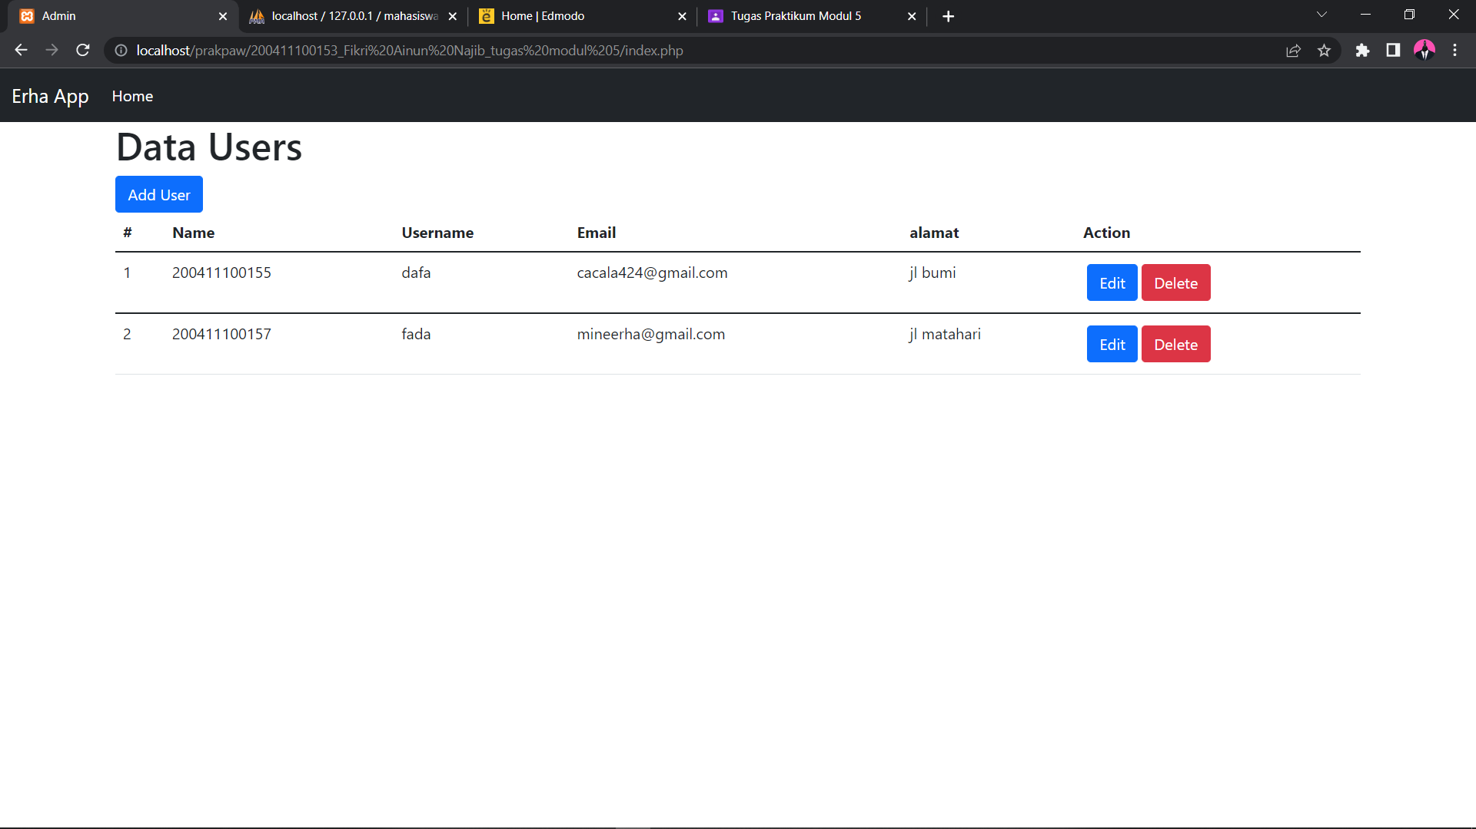

**Source Code menambahkan:**

|  |
| --- |
| <?php  session_start();  ?>  <!doctype html>  <html lang="en">  <head>  <!-- Required meta tags -->  <meta charset="utf-8">  <meta name="viewport" content="width=device-width, initial-scale=1">  <!-- Bootstrap CSS -->  <link href="https://cdn.jsdelivr.net/npm/bootstrap@5.1.3/dist/css/bootstrap.min.css" rel="stylesheet"  integrity="sha384-1BmE4kWBq78iYhFldvKuhfTAU6auU8tT94WrHftjDbrCEXSU1oBoqyl2QvZ6jIW3" crossorigin="anonymous">  <title>Add Data User</title>  </head>  <body>  <nav class="navbar navbar-expand-lg navbar-dark bg-dark">  <div class="container-fluid">  <a class="navbar-brand" href="#">Erha App</a>  <button class="navbar-toggler" type="button" data-bs-toggle="collapse"  data-bs-target="#navbarSupportedContent" aria-controls="navbarSupportedContent" aria-expanded="false"  aria-label="Toggle navigation">  <span class="navbar-toggler-icon"></span>  </button>  <div class="collapse navbar-collapse" id="navbarSupportedContent">  <ul class="navbar-nav me-auto mb-2 mb-lg-0">  <li class="nav-item">  <a class="nav-link active" aria-current="page" href="index.php">Home</a>  </li>  </ul>  </div>  </div>  </nav>  <div class="container">  <h1>Add Users</h1>  <?php  if (!empty($_SESSION['message'])) {  echo '<div class="alert alert-warning" role="alert">' . $_SESSION['message'] . '</div>';  unset($_SESSION['message']);  }  ?>  <form method="POST" action="proses.php">  <div class="mb-3">  <label for="nrp" class="form-label">NRP</label>  <input type="number" class="form-control" id="nrp" name="nrp" required placeholder="Input Nrp">  </div>  <div class="mb-3">  <label for="nama" class="form-label">nama</label>  <input type="text" class="form-control" id="nama" name="nama" required placeholder="Input nama">  </div>  <div class="mb-3">  <label for="email" class="form-label">Email address</label>  <input type="email" class="form-control" id="email" name="email" required placeholder="Input Email">  </div>  <div class="mb-3">  <label for="alamat" class="form-label">alamat</label>  <input type="text" class="form-control" id="alamat" name="alamat" required placeholder="Input Userame">  </div>  <button type="submit" class="btn btn-primary">Submit</button>  </form>  </div>  <!-- Optional JavaScript; choose one of the two! -->  <!-- Option 1: Bootstrap Bundle with Popper -->  <script src="https://cdn.jsdelivr.net/npm/bootstrap@5.1.3/dist/js/bootstrap.bundle.min.js"  integrity="sha384-ka7Sk0Gln4gmtz2MlQnikT1wXgYsOg+OMhuP+IlRH9sENBO0LRn5q+8nbTov4+1p" crossorigin="anonymous">  </script>  <!-- Option 2: Separate Popper and Bootstrap JS -->  <!--  <script src="https://cdn.jsdelivr.net/npm/@popperjs/core@2.10.2/dist/umd/popper.min.js" integrity="sha384-7+zCNj/IqJ95wo16oMtfsKbZ9ccEh31eOz1HGyDuCQ6wgnyJNSYdrPa03rtR1zdB" crossorigin="anonymous"></script>  <script src="https://cdn.jsdelivr.net/npm/bootstrap@5.1.3/dist/js/bootstrap.min.js" integrity="sha384-QJHtvGhmr9XOIpI6YVutG+2QOK9T+ZnN4kzFN1RtK3zEFEIsxhlmWl5/YESvpZ13" crossorigin="anonymous"></script>  -->  </body>  </html> |

**Screenshot :**

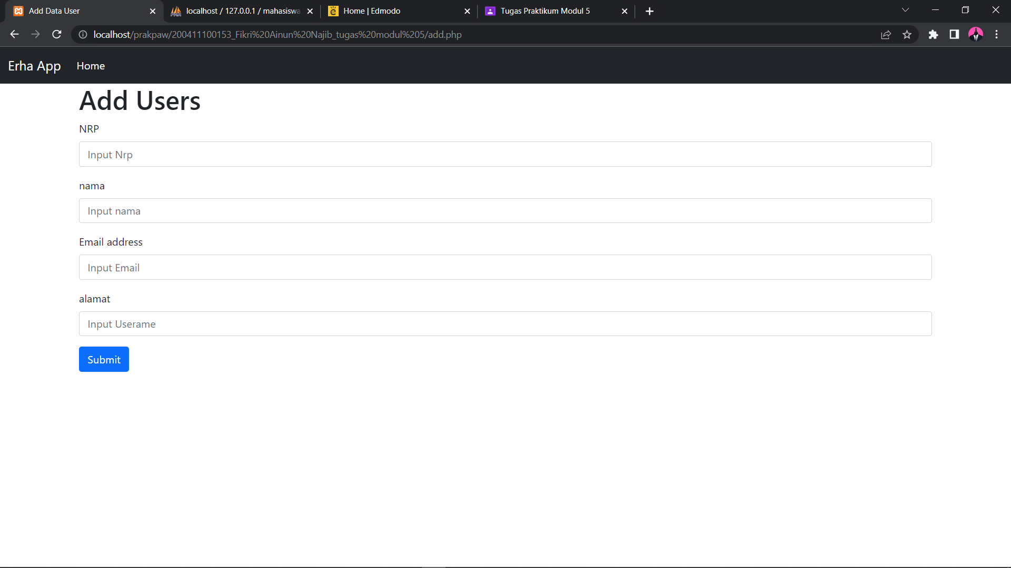

**Source Code mengedit:**

|  |
| --- |
| <?php  session_start();  require('database/connect.php');  $nrp = $_GET['nrp'];  $sql = "SELECT * FROM tbl_mahasiswa WHERE nrp = $nrp";  $result = mysqli_query($conn, $sql);  $row = mysqli_fetch_assoc($result);  #update data to database  if (isset($_POST['submit'])) {  $nrpp = $_POST['nrp'];  $nama = $_POST['nama'];  $email = $_POST['email'];  $alamat = $_POST['alamat'];  if ($row['nama'] == $nama && $row['email'] == $email && $row['alamat'] == $alamat) {  $_SESSION['message'] = "No changes made";  header('Location: index.php');  exit();  }  $sql2 = "UPDATE `tbl_mahasiswa` SET `nama` = '$nama', `email` = '$email', alamat = '$alamat' WHERE `nrp` = '$nrpp'";  if ($conn->query($sql2) === TRUE) {  $_SESSION['message'] = "User updated successfully";  header('Location: index.php');  exit();  } else {  echo "Error: " . $sql2 . "<br>" . $conn->error;  }  }  ?>  <!doctype html>  <html lang="en">  <head>  <!-- Required meta tags -->  <meta charset="utf-8">  <meta name="viewport" content="width=device-width, initial-scale=1">  <!-- Bootstrap CSS -->  <link href="https://cdn.jsdelivr.net/npm/bootstrap@5.1.3/dist/css/bootstrap.min.css" rel="stylesheet"  integrity="sha384-1BmE4kWBq78iYhFldvKuhfTAU6auU8tT94WrHftjDbrCEXSU1oBoqyl2QvZ6jIW3" crossorigin="anonymous">  <title>Edit Data User</title>  </head>  <body>  <nav class="navbar navbar-expand-lg navbar-dark bg-dark">  <div class="container-fluid">  <a class="navbar-brand" href="#">Erha App</a>  <button class="navbar-toggler" type="button" data-bs-toggle="collapse"  data-bs-target="#navbarSupportedContent" aria-controls="navbarSupportedContent" aria-expanded="false"  aria-label="Toggle navigation">  <span class="navbar-toggler-icon"></span>  </button>  <div class="collapse navbar-collapse" id="navbarSupportedContent">  <ul class="navbar-nav me-auto mb-2 mb-lg-0">  <li class="nav-item">  <a class="nav-link active" aria-current="page" href="index.php">Home</a>  </li>  </ul>  </div>  </div>  </nav>  <div class="container">  <h1>Edit Data User</h1>  <?php  if (!empty($_SESSION['message'])) {  echo '<div class="alert alert-warning" role="alert">' . $_SESSION['message'] . '</div>';  unset($_SESSION['message']);  }  ?>  <form method="POST" action="">  <input type="number" hidden value="<?php echo $row['nrp'] ?>" name="nrp">  <div class="mb-3">  <label for="nama" class="form-label">Nama</label>  <input type="text" class="form-control" id="nama" name="nama" value="<?php echo $row['nama'] ?>"  required placeholder="Input nama">  </div>  <div class="mb-3">  <label for="email" class="form-label">Email address</label>  <input type="email" class="form-control" id="email" name="email" value="<?php echo $row['email'] ?>"  required placeholder="Input Email">  </div>  <div class="mb-3">  <label for="alamat" class="form-label">alamat</label>  <input type="text" class="form-control" id="alamat" name="alamat" value="<?php echo $row['alamat'] ?>"  required placeholder="Input alamat">  </div>  <button type="submit" name="submit" class="btn btn-primary">Submit</button>  </form>  </div>  <!-- Optional JavaScript; choose one of the two! -->  <!-- Option 1: Bootstrap Bundle with Popper -->  <script src="https://cdn.jsdelivr.net/npm/bootstrap@5.1.3/dist/js/bootstrap.bundle.min.js"  integrity="sha384-ka7Sk0Gln4gmtz2MlQnikT1wXgYsOg+OMhuP+IlRH9sENBO0LRn5q+8nbTov4+1p" crossorigin="anonymous">  </script>  <!-- Option 2: Separate Popper and Bootstrap JS -->  <!--  <script src="https://cdn.jsdelivr.net/npm/@popperjs/core@2.10.2/dist/umd/popper.min.js" integrity="sha384-7+zCNj/IqJ95wo16oMtfsKbZ9ccEh31eOz1HGyDuCQ6wgnyJNSYdrPa03rtR1zdB" crossorigin="anonymous"></script>  <script src="https://cdn.jsdelivr.net/npm/bootstrap@5.1.3/dist/js/bootstrap.min.js" integrity="sha384-QJHtvGhmr9XOIpI6YVutG+2QOK9T+ZnN4kzFN1RtK3zEFEIsxhlmWl5/YESvpZ13" crossorigin="anonymous"></script>  -->  </body>  </html> |

**Screenshot :**

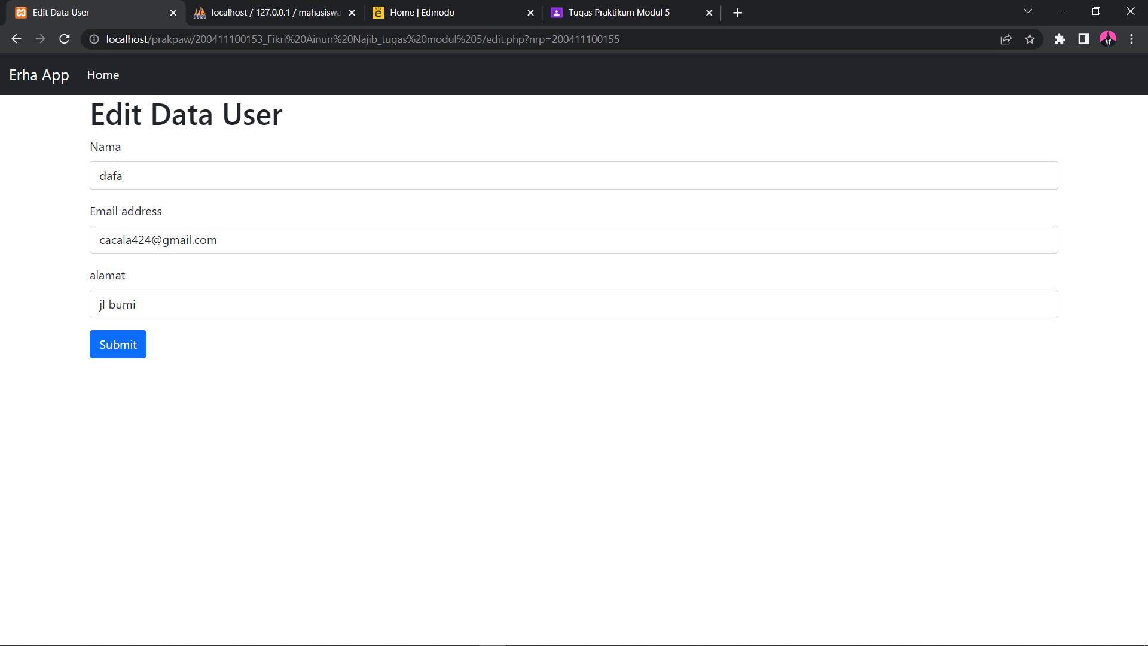

**Source Code proses menambahkan:**

|  |
| --- |
| <?php  session_start();  // redirect to database\connect.php  require('database/connect.php');  $nrp = $_POST['nrp'];  $nama = $_POST['nama'];  $alamat = $_POST['alamat'];  $email = $_POST['email'];  // echo $nrp;  // echo $nama;  // echo $alamat;  // echo $email;  #check data on database  $checkuser = "SELECT * FROM tbl_mahasiswa WHERE nrp = '$nrp' OR email = '$email'";  $result = mysqli_query($conn, $checkuser);  if (mysqli_num_rows($result) > 0) {  $_SESSION['message'] = "Username Or Email already exist";  header('Location: add.php');  } else {  # Insert data to database  $sql = "INSERT INTO tbl_mahasiswa (nrp,nama,email, alamat) VALUES ('$nrp','$nama','$email', '$alamat')";  if ($conn->query($sql) === TRUE) {  $_SESSION['message'] = "New User created successfully";  header('Location: index.php');  } else {  echo "Error: " . $sql . "<br>" . $conn->error;  }  } |

**Source Code menghapus:**

|  |
| --- |
| <?php  require('database/connect.php');  #delete data from database  session_start();  if (isset($_GET['nrp'])) {  $nrp = $_GET['nrp'];  $sql = "DELETE FROM tbl_mahasiswa WHERE nrp = $nrp";  if ($conn->query($sql) === TRUE) {  $_SESSION['message'] = "User deleted successfully";  header('Location: index.php');  } else {  echo "Error: " . $sql . "<br>" . $conn->error;  }  } |